Help Support the Crested Butte
Adaptive Sports Center
Every year the Federation chooses an organization to support that is local to where our annual meeting takes place | 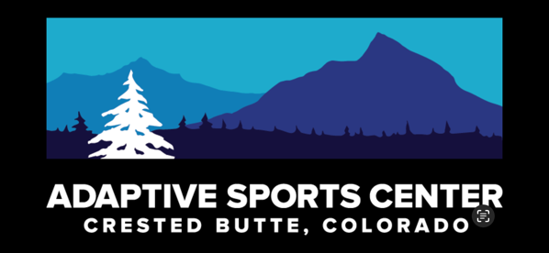

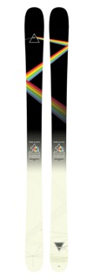 | The National Ski Council Federation is raffling off a pair of Icelantic Skis, limited Pink Floyd Edition Nomad 100 169cm    Raffle tickets are $20 each or 3 for $50.  Cash, Check and Venmo Accepted  To purchase raffle tickets, email Michael  Calderone at skimikec@aol.com  Drawing will be held Saturday August 23rd, 2025, at the NSCF Annual Meeting in Crested Butte  All proceeds will go to Crested Butte Adaptive Sports Center.

